REGIONAL FINANCIAL INVESTIGATIONS ACTIVITY TOOK PLACE IN NORTH MACEDONIA

You are here

[Home](https://www.cepol.europa.eu/) » [Media](https://www.cepol.europa.eu/media) » [News](https://www.cepol.europa.eu/media/news) » Regional financial investigations activity took place in North Macedonia



13 November 2019

**CEPOL delivered a regional training on financial nvestigations related to corruption between 4-8 November 2019, in Skopje, North Macedonia,**

The course brought together in total 48 law enforcement officials, Financial Investigation Unit officials, prosecutors and judges from 14 EU Member States and six Western Balkan jurisdictions. The training hosted 9 experts as guest speakers and trainers from different countries and institutions who presented case studies from Albania, Belgium, Croatia, Germany, Hungary, Italy, North Macedonia, Poland and Spain.

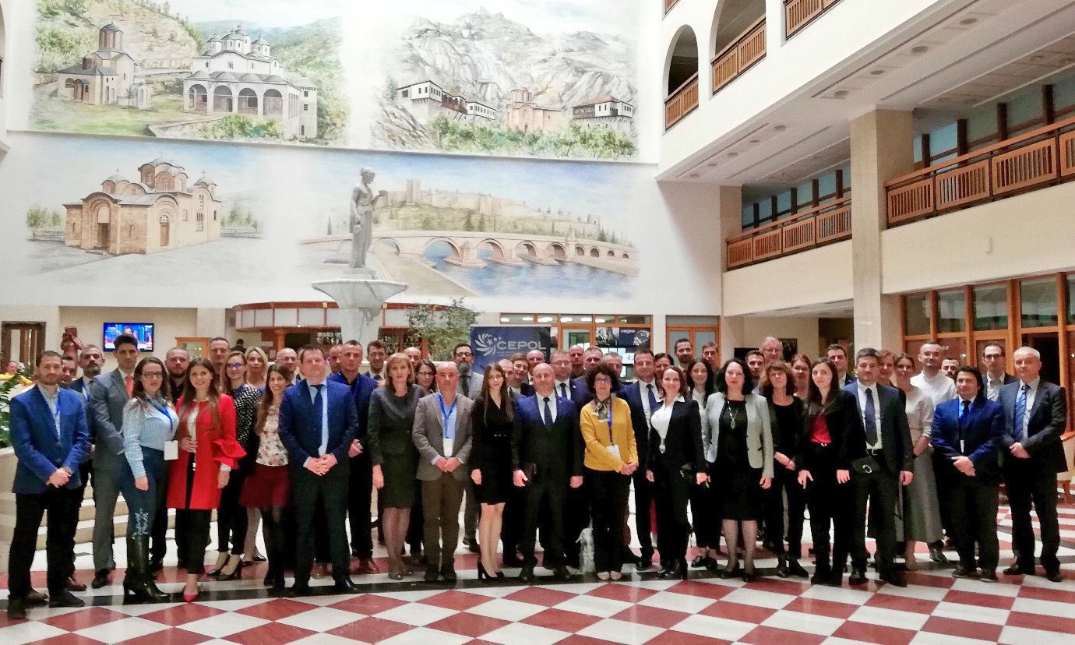

The objectives of the training were:

1. ​To identify practical and legal challenges of investigating and prosecuting corruption
2. To enhance knowledge on the instruments and techniques of FI in the fight against corruption
3. To improve, update and share best practices and knowledge about EU and cooperation possibilities
4. To increase the protection of the financial interest of the Union
5. To create sustainable professional networks

Representatives/experts from Europol, GIZ, CILC and the Italian Ministry of Interior provided valuable insight into their activities and presented cases related to the course topic. The North Macedonian CEPOL National Contact Point as representative of the Ministry of Internal Affairs was present at the closing of the activity.

The next training activity within the Western Balkans Financial Investigation In-Service Training Project **'Mock Trial II.'**will take place in Pristina, Kosovo* **from 17 to 22 November 2019**.

The Project is funded by the European Commission under the Instrument for Pre-Accession Assistance (IPAII) and it is an integral part of the second IISG Pillar (WBCSCi).

*\* The designation is without prejudice to positions on status, and is in line with UNSCR 1244 and the ICJ Opinion on the Kosovo Declaration of Independence.*